**Attendance**

| **DAY** | Abhishek Poudel | Amulya Shrestha | Biliyas Maharjan | Biraj Shrestha | Shasank Shrestha | Soya Shrestha | Sushan Bhandari |
| --- | --- | --- | --- | --- | --- | --- | --- |
| 1(5th March) | P | P | P | P | P | P | P |
| 2(6th March) |  | P | P | P | P | P | P |
| 3(7th March) | P | P | P | P | P | P | P |
| 4(8th March) | P | P | P | P | P | P |  |
| 5(15th March) | P | P | P | P | P | P | P |
| 6(16th March) | P | P | P | P | P | P | P |
| 7(17th March) | P | P | P | P | P | P | P |
| 8(18th March) | P | P | P | P | P | P | P |
| 9(21st March) | P | P | P | P | P | P | P |
| 10(22nd March) | P | P | P | P | P | P | P |
| 11(24th March) | P | P | P | P | P | P | P |
| 12(26th March) | P | P | P | P | P | P | P |
| 13(28th March) |  | P | P | P | P | P | P |
| 14(2nd April) | P | P | P | P | P | P | P |
| 15(7th April) | P |  | P |  | P |  |  |
| 16(9th April) | P | P | P | P | P | P | P |
| 17(11th April) | P | P | P |  | P | P | P |
| 18(14th April) |  |  | P |  | P | P | P |
| 19(14th April (online)) | P | P | P | P | P | P | P |
| 19(17th April) |  | P | P | P | P | P | P |
| 20(18th April) | P | P | P |  | P |  | P |
| 21(19th April) | P | P | P | P | P | P | P |
| 21(19th April )(Online) | P | P | P | P | P | P | P |
| 22(21st April) | P | P | P | P | P | P | P |
| 22(21st April)(online) | P | P | P | P | P | P | P |
| 23(23rd April) | P | P | P | P | P | P | P |
| 24(24th April) | P | P | P | P | P | P | P |
| 25(25th April) | P | P | P |  | P | P | P |
| 26(28th April) | P | P | P |  | P | P | P |
| 27(29th April) |  | P | P |  | P | P | P |
| 27(29th April) | P | P |  | P | P | P | P |
| 28(1st May) | P | P | P |  | P |  | P |
| 29 (6th May) | P |  |  | P | P | P |  |
| 30 (11th May) | P | P | P | P | P | P | P |
| 31 (12th May) |  | P | P | P | P | P | P |
| 32 (15th May) | P |  | P | P | P | P | P |
| 31 (16th May) | P |  | P | P | P | P |  |
| 32(17th May) | P | P | P | P | P |  | P |
| 33(18th May) | P | P | P | P | P | P | P |
| 34(19th May) | P | P | P | P | P | P |  |
| 35(20th May) |  | P | P | P | P | P | P |
| 36(21st May) | P | P | P | P | P | P | P |
| 37 (22nd May) | P | P | P | P | P | P | P |
| 38 (23rd May) | P | P | P | P | P | P | P |
| 39 (24th May) |  | P | P | P | P | P | P |
| 40 (25th May) |  |  | P |  | P | P |  |
| 41(26th May) | P | P | P | P | P | P | P |

**Daily Record**

**Day1 (5th March 2024) 7 pm to 8.30 pm(online)**

* Introduction of the team members.
* Division of work among the team members.
* Website name decided (i.e.CleckShopHub).

**Day2 (7th March 2024) 7 pm to 8:20 Pm (online)**

* Began with the contract work and project charter.
* Deliberation and agreement on the project contract.

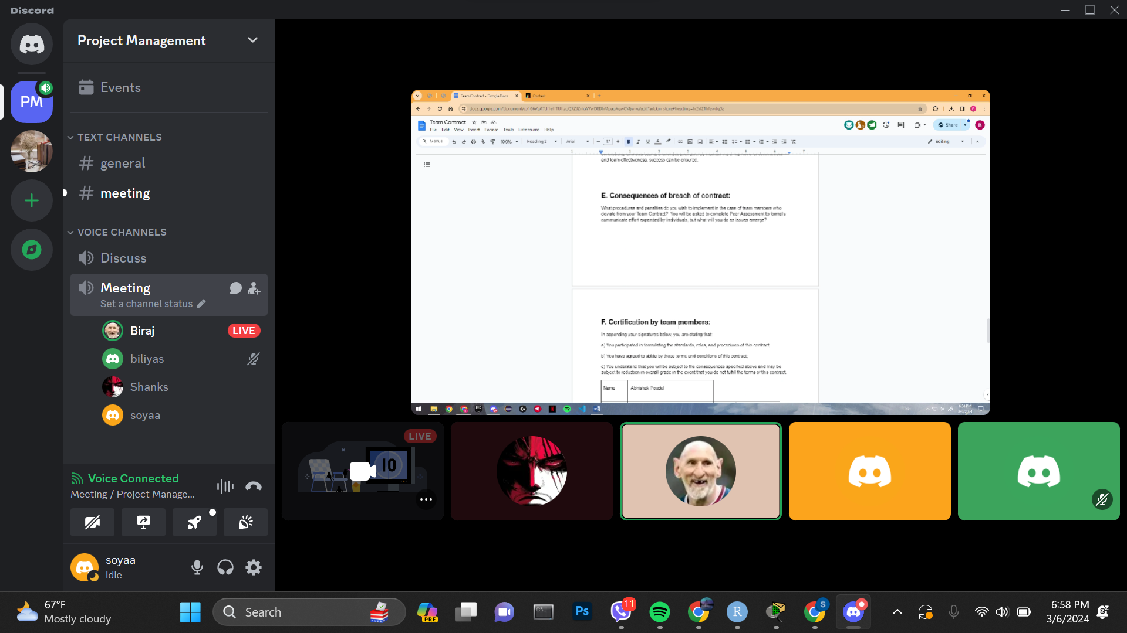

Discussing the team contract

**Day3 (7th March 2024) 10:40 am to 12:50 Pm(Physical)**

* The signing of team contract
* Division of work among the members
* Concluded project charter

**Day4 (8th March 2024) 10:25 am to 11.05(Online)**

* Submission of team contract and project charter

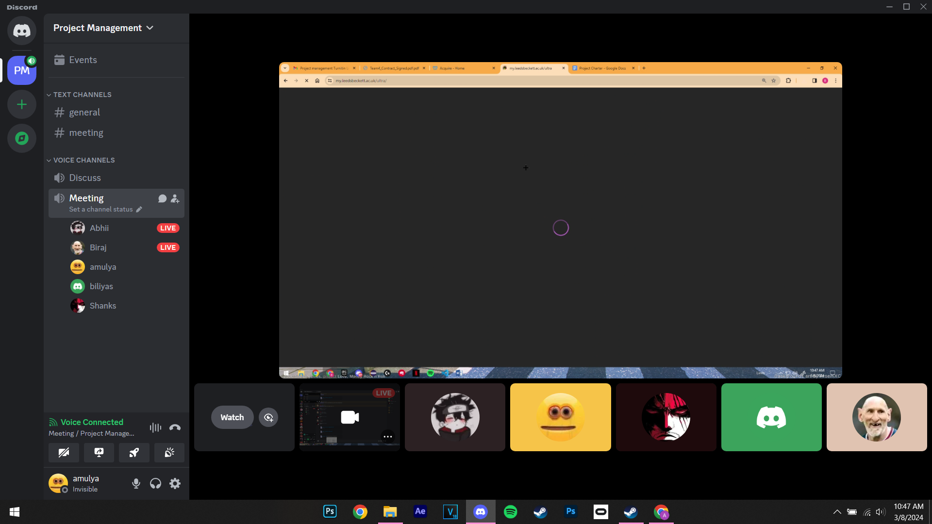

**Day 5 (15th March 2024) 11:00 am to 12:30 PM (Physical)**

* Reflected upon individual strengths and weaknesses for Skill audit.
* Decided and discussed suitable Belbin roles for each member.

**Day 6 (16th March 2024) 7pm to 8:40 Pm(Online)**

* Prepared ERD diagram to design database models used in our site.

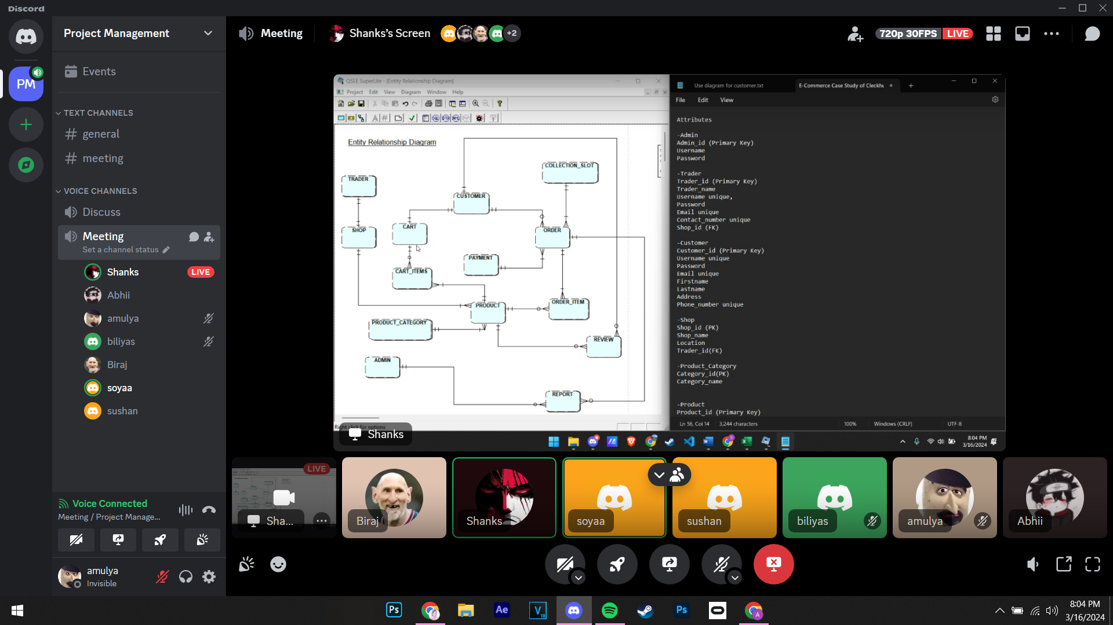

**Day 7 (17th March 2024) 11 am to 1:45 Pm (Physical)**

* Finalized the Skill audit and Belbin Analysis.
* Continued to operate on the ERD diagram.

**Day 8 (18th March 2024) 10 am to 11 am (Physical)**

* Began creating the wireframes for the web pages using Figma.
* Continued working on the ERD.
* Discussion on the logo.
* Started designing a website logo
* Commenced work on the wireframe.

**Day 9 (21st March 2024) 8:00 pm to 8:40 pm (Online)**

* EERD/ERD/Final Composite & Decomposition ERD/ Logical Table discussion and submission.
* Continued making wireframes.

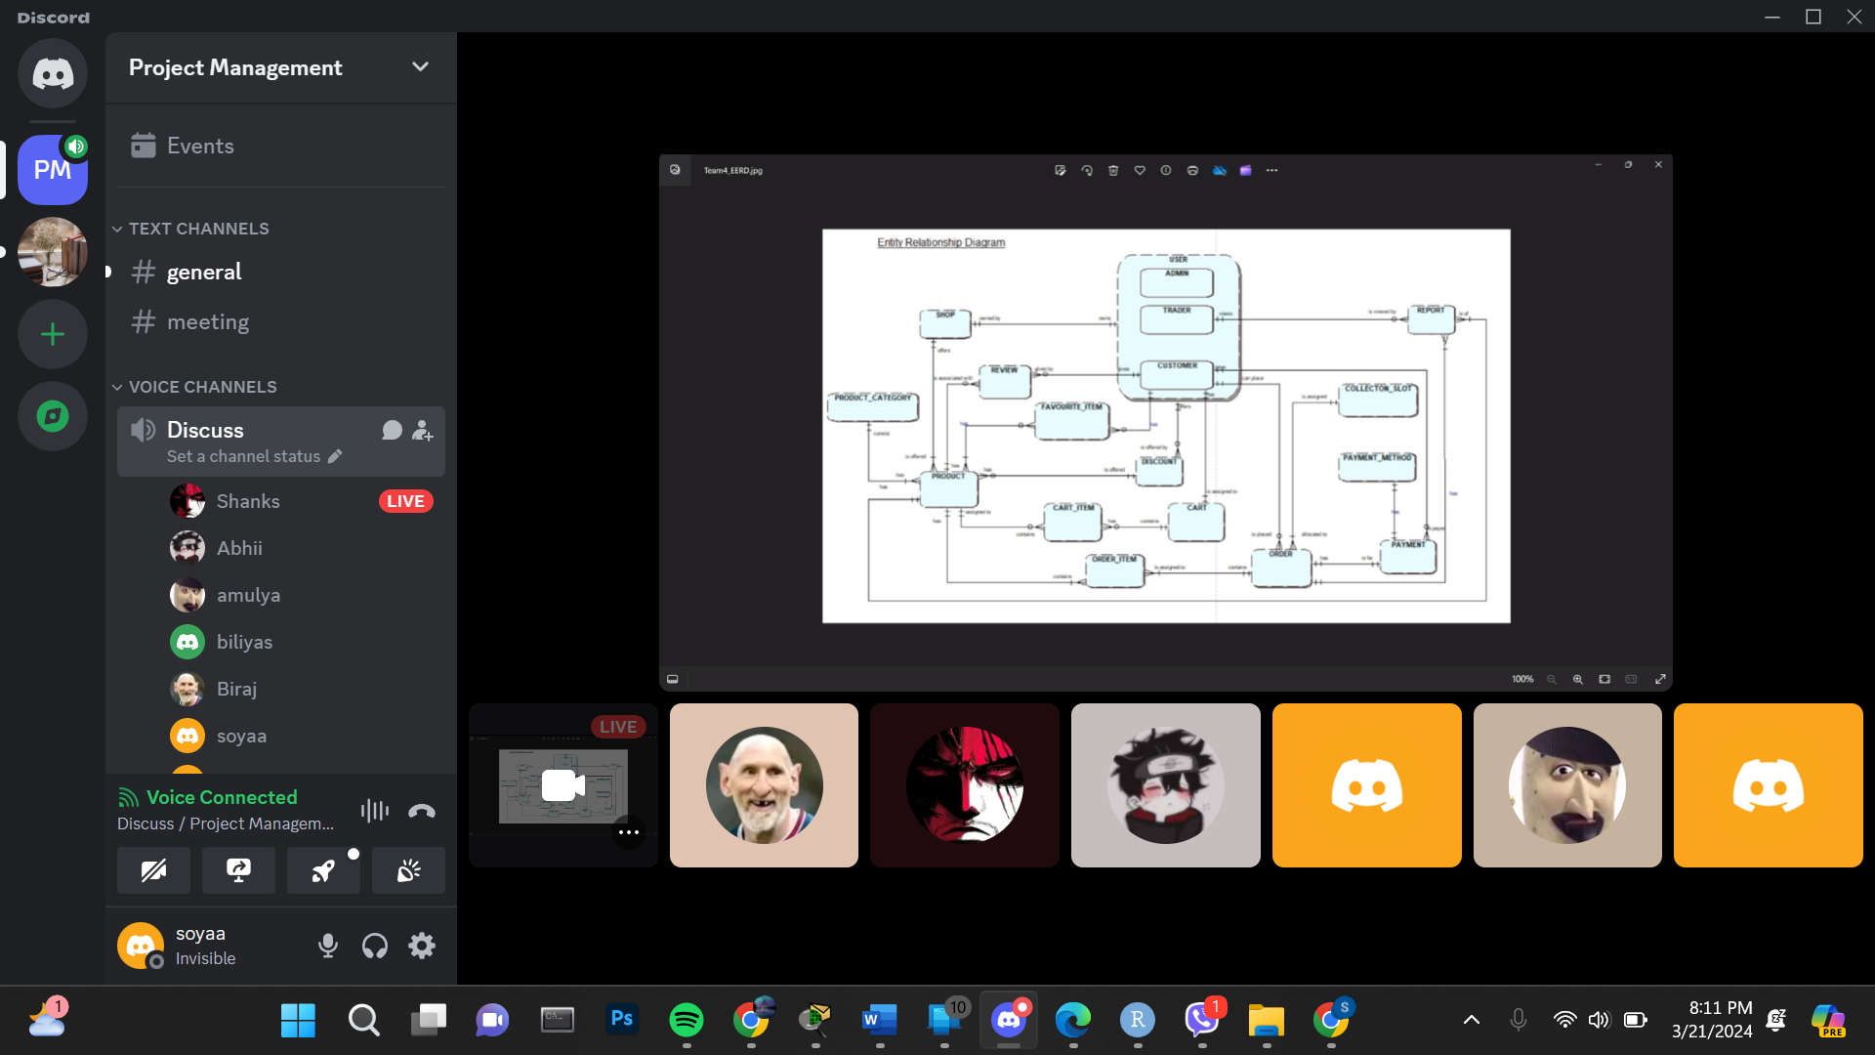

EERD/ERD/Final Composite & Decomposition ERD/ Logical Table discussion

**Day 10 (22nd March 2024) 10:00 Am to 11:00 am (Physical)**

**7:30 pm to 9 pm (Online)**

* Started working on Use Case Diagram
* Continued on Wireframe.
* Started working on use case diagram
* Discussion on Functional and Non-Functional Requirements.

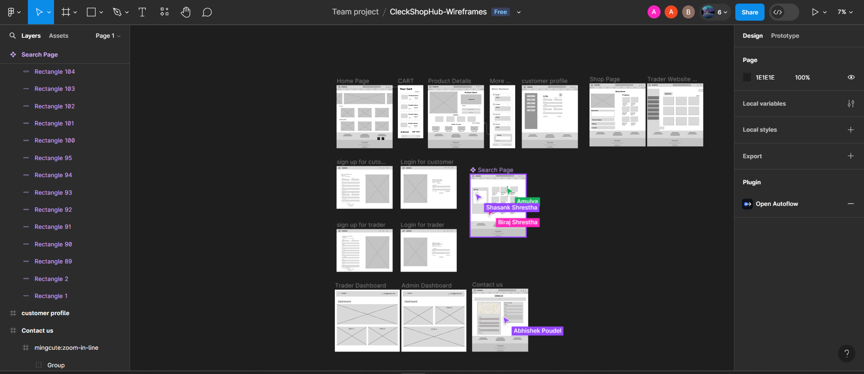

Making of wireframes

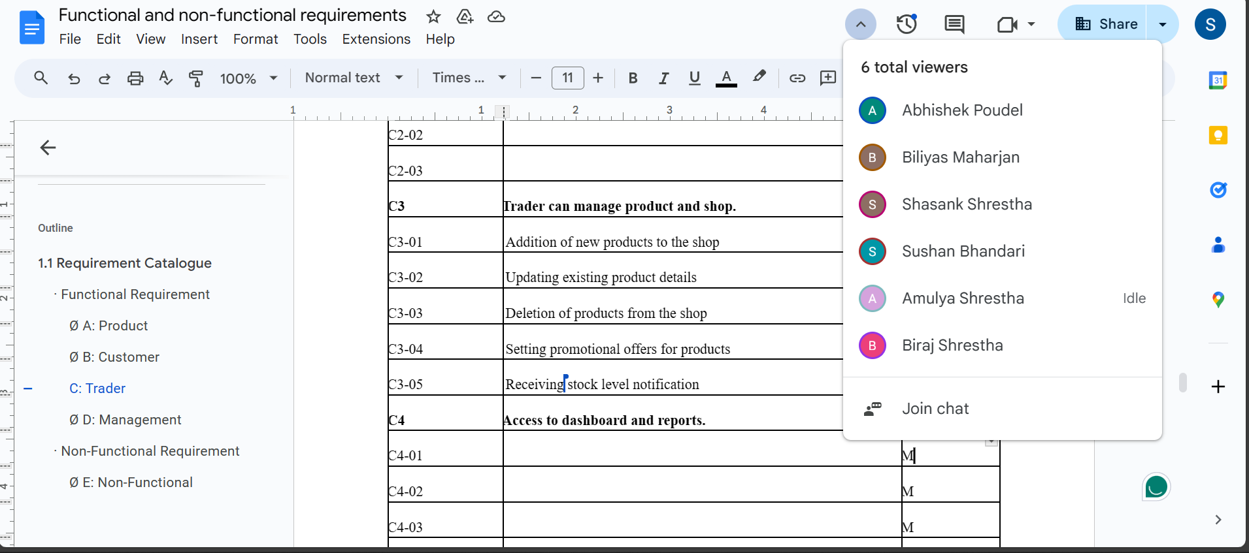

Discussion on functional and non-functional requirements

**Day 11 (24th March 2024) 8:00 Am to 8:35 Am(Online)**

* Finalizing Wireframe
* Submission of wireframe and logo for the website.

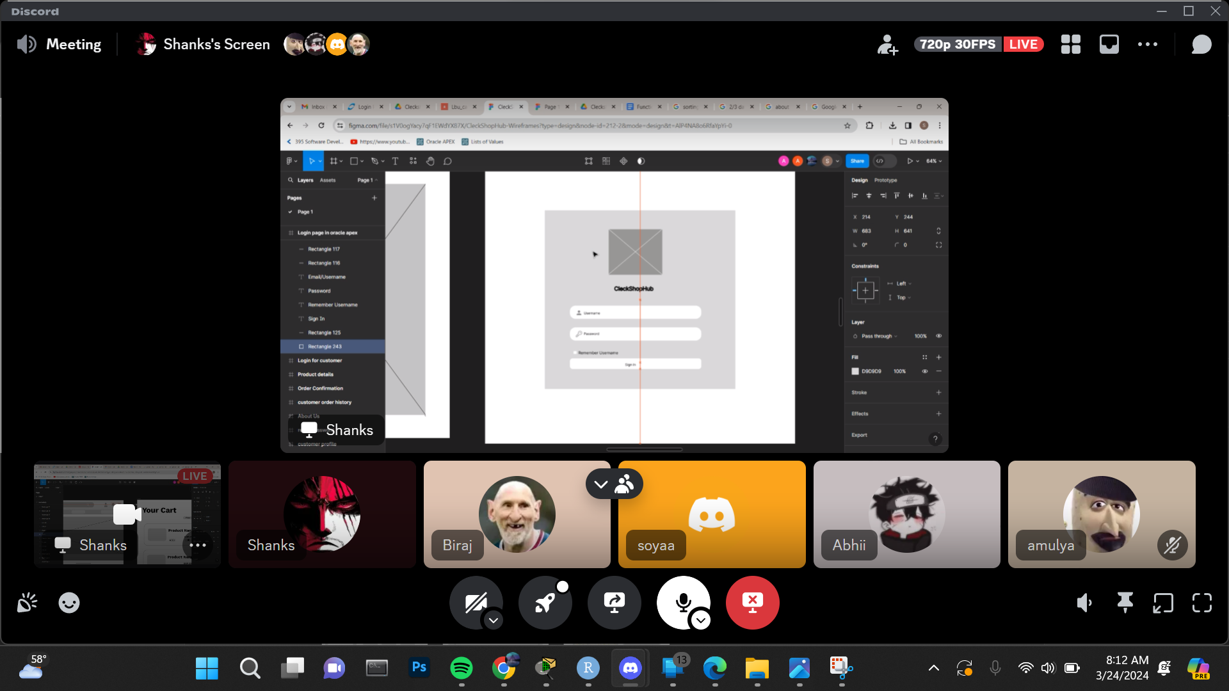

**Day 12 (26th March 2024) 7:30 pm to 8:15 pm(Online)**

* Finalizing Use Case Diagram
* Discussion on Functional and Non-Functional Requirements.

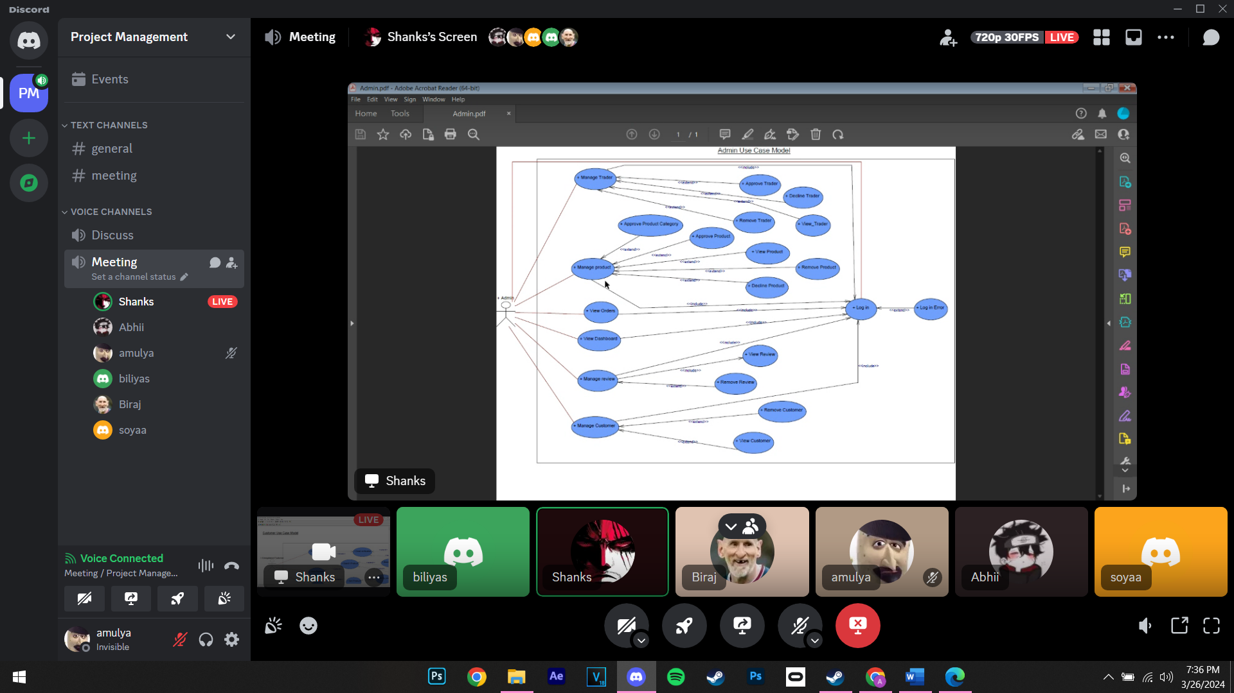

**Day 13 (28th March 2024) 7:30 pm to 7:50 pm(Online)**

* Submission of Usecase diagram and functional and non-functional requirements.

**Day 14 (2nd April 2024) 9:00 am to 10:30 am(Physical)**

* Discussion on how to further proceed on the project
* Division on individual work (HTML, CSS)
* Table created in the database

**Day 15 (7th April 2024) 7:30 Pm to 8:40 Pm(Online)**

* Checked on individual progress.
* Discussion on what changes should be made in HTML and CSS
* Triggers were created in the database

**Day 16 (9th April 2024) 9:30 am to 10:40 am(Physical)**

* Finalized the HTML and CSS work and decided how to combine individual works.
* Individual work was pushed, creating each folder in the GIT hub.

**Day 17 (11th April 2024) 6:30 pm to 7:30 pm(Online)**

* Discussion on work progress and how to proceed further with the project

**Day 18 (14th April 2024) 9:30 am to 11:40 am (Physical)**

* Commenced working on MS Project.

**Day 18 (14th April 2024) 7:30 pm to 8:40pm(Online)**

* Started maintaining schedules on MS Project

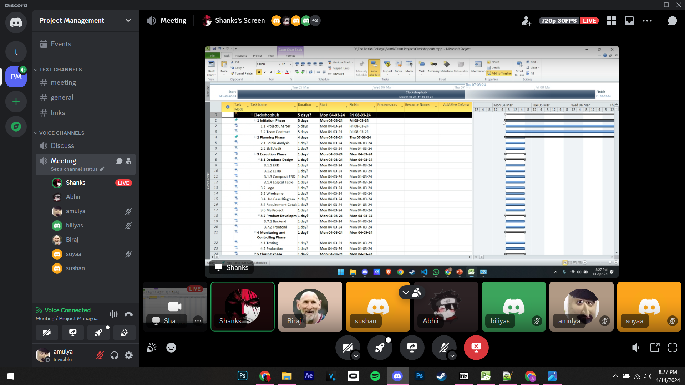

**Day 19 (17th April 2024) 9:00 am to 11:05 am(Physical)**

* Continued working on MS Project.
* Worked on slides for Work In Progress
* Discussion on website (PHP, HTML, CSS)

**Day 20 (18th April 2024) 7:30 Pm to 8:00 Pm(Online)**

* Prepared Gantt Chart and TimeLine
* 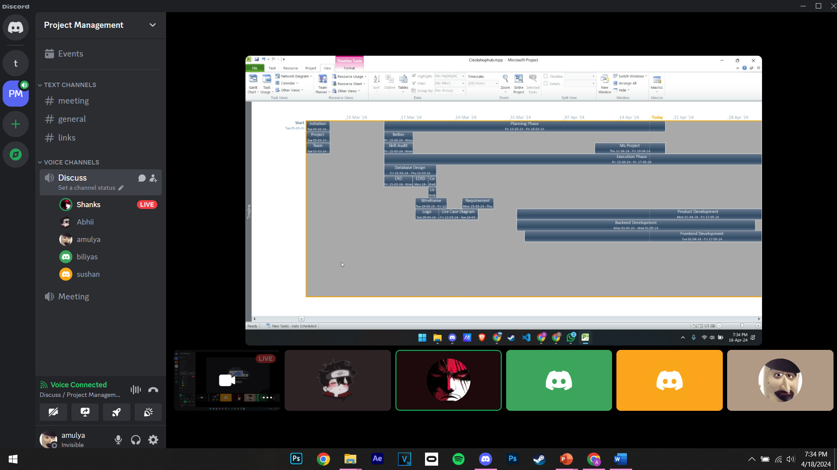

**Day 21 (19th April 2024) 12:00 pm to 1:00 pm(Physical)**

* Finalized ms project
* Made necessary changes in slides and Word files for WIP

**Day 21 (19th April 2024) 8:00 pm to 9:00 pm (Online)**

* Submission of MS Project

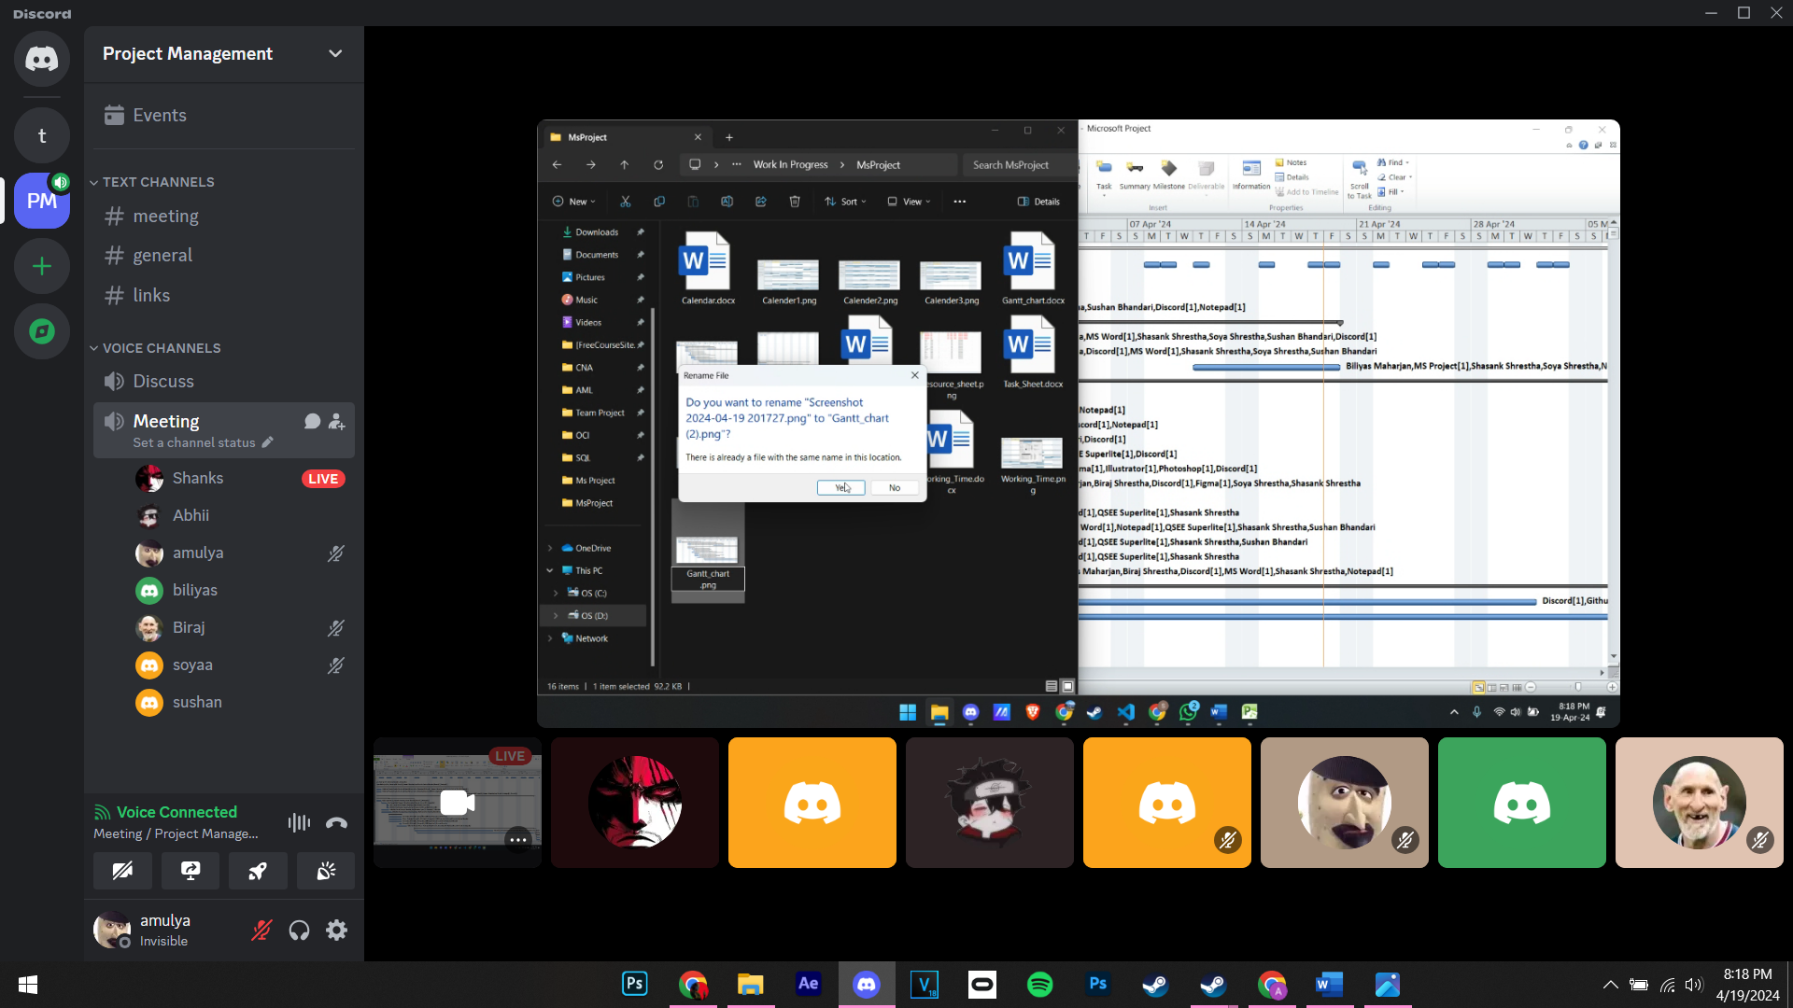

**Day 22 (21st April 2024) 12:00 pm to 2:00 pm (Physical)**

* Finalized WIP files
* Presentation preparation

**Day 22 (21st April 2024) 8:00 pm to 9:00 pm(Online)**

* Submission of WIP files

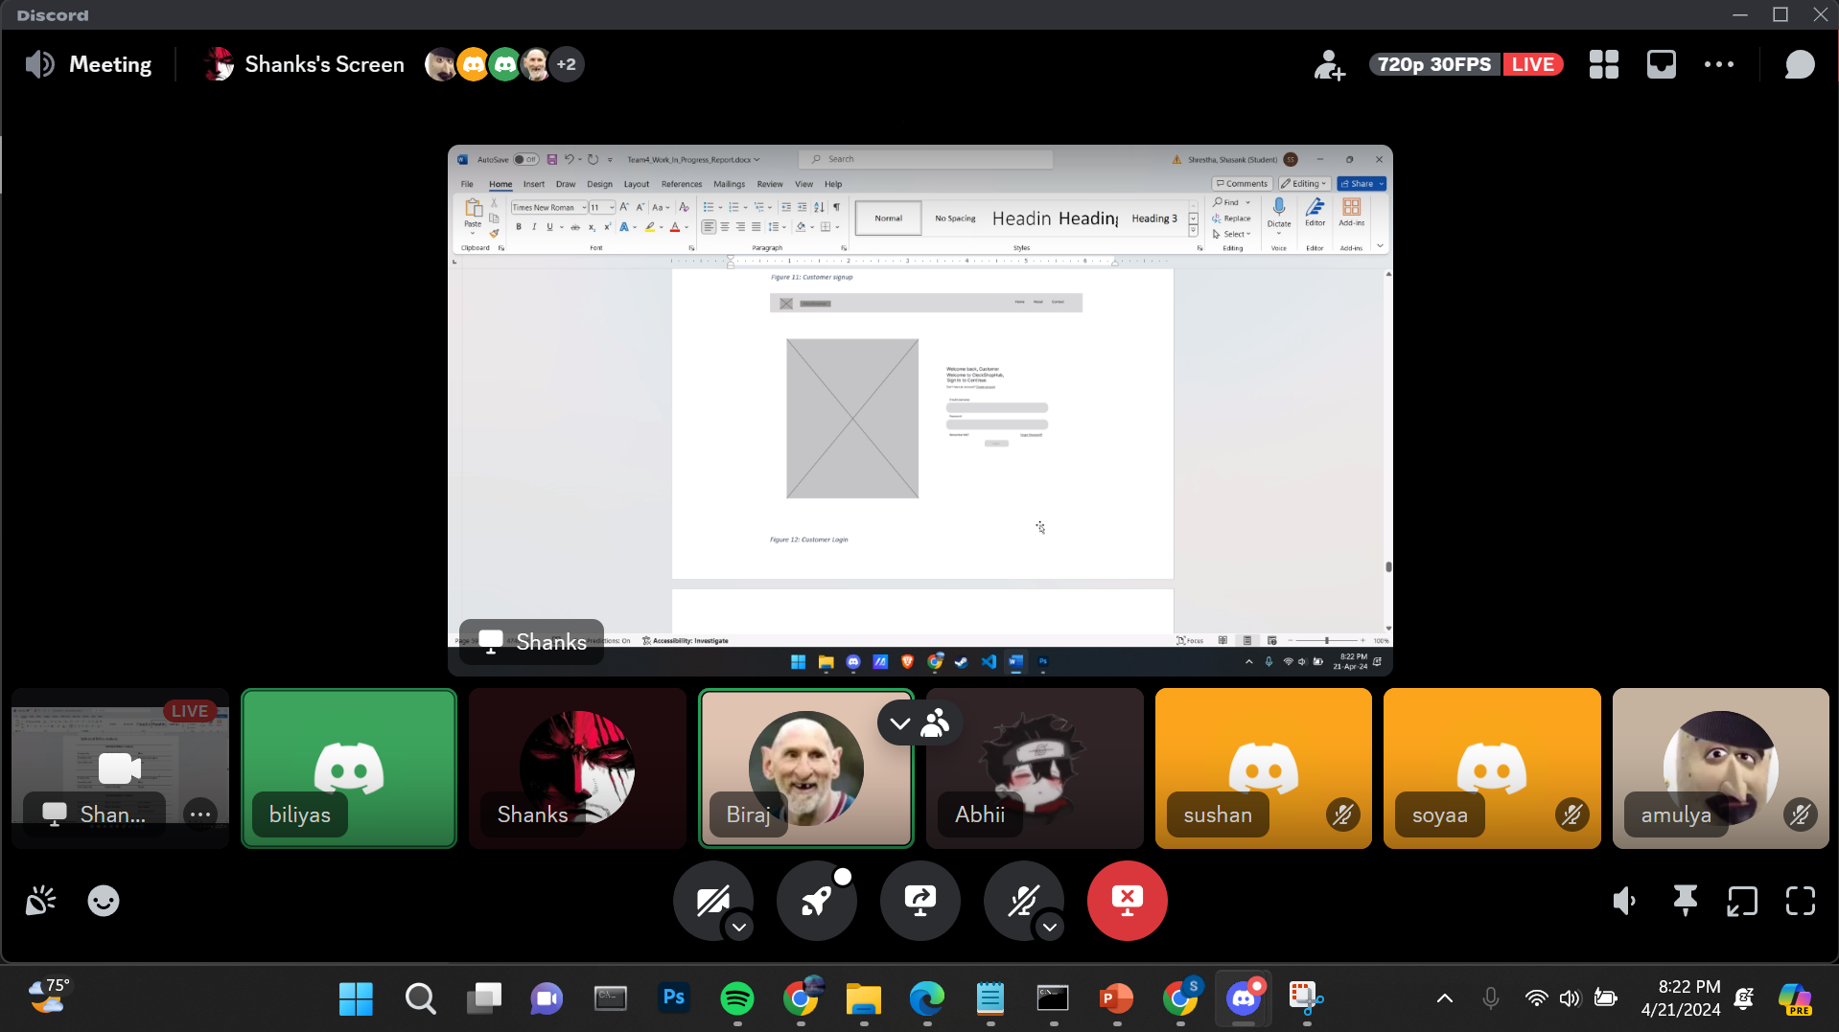

**Day 23 (23rd April 2024) 8:00 pm to 9:00 pm(Online)**

* Troubleshooting OCI connection

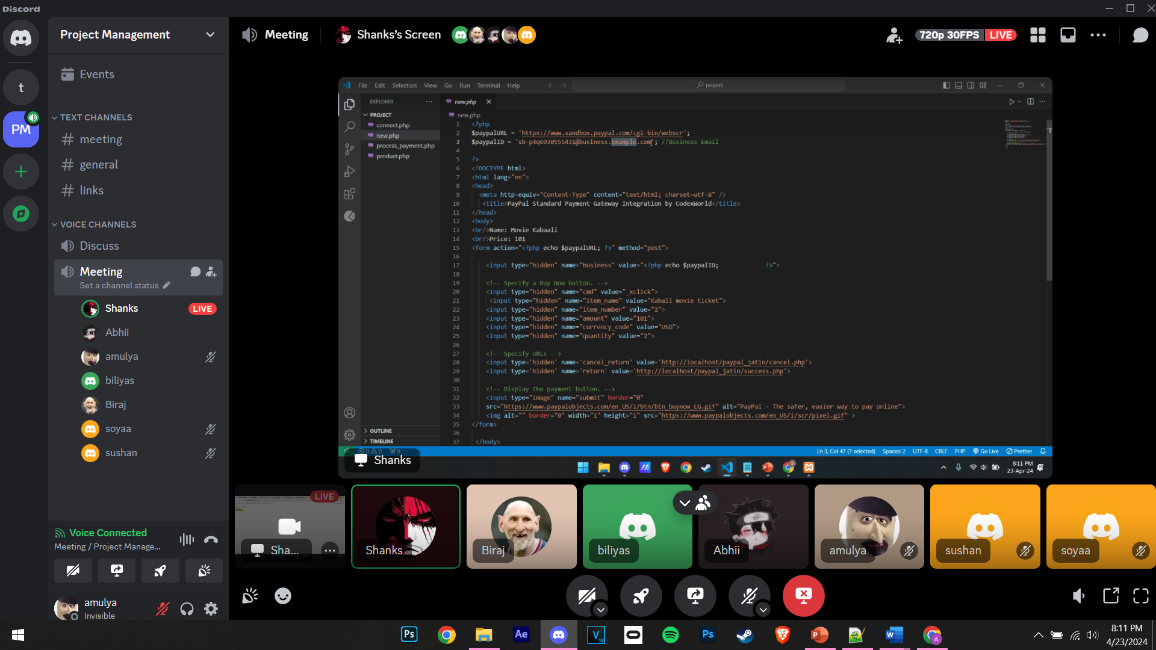

**Day 24 (24th April 2024) 1:30 pm to 2:40 pm(Physical)**

* Prepared and practiced speech for WIP presentation

**Day 25 (28th April 2024) 11:30 am to 3:00 pm(Physical)**

* Prepared and practiced speech for WIP presentation
* OCI connection
* Continued with PHP coding

**Day 26 (29th April 2024) 10:00 am to 11:00 am(Physical)**

* Practiced speech for WIP presentation

**Day 26 (29th April 2024) 8:30 pm to 9:30 pm(Online)**

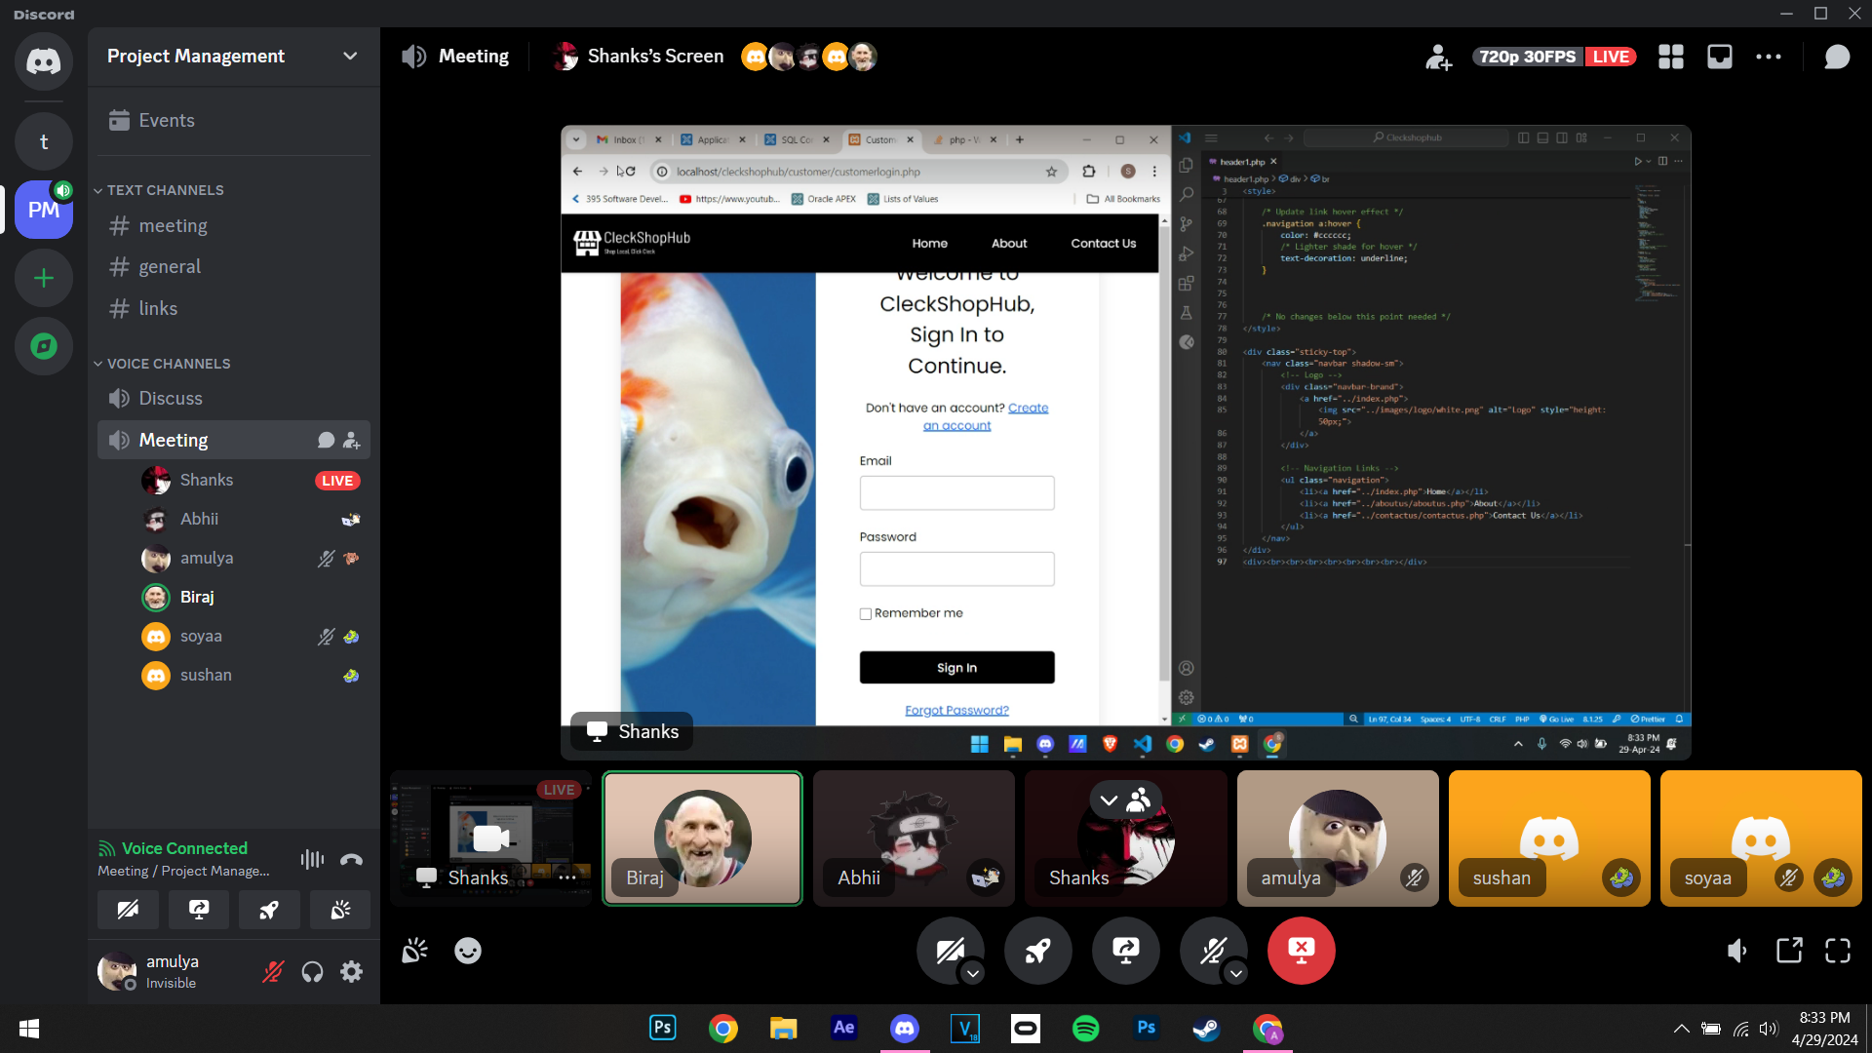

* Made necessary changes to the existing pages

**Day 27 (1st May 2024) 11:30 am to 1:45 am(Physical)**

* Final Demo presentation before the WIP Presentation

**Day 28 (6th May 2024) 7:40 pm to 8:30pm(Online)**

* Divided the parts for the front-end part

**Day 29 (11th May 2024) 7:50 pm to 8:50pm(Online)**

* Discussion on the progress of PHP coding and database.

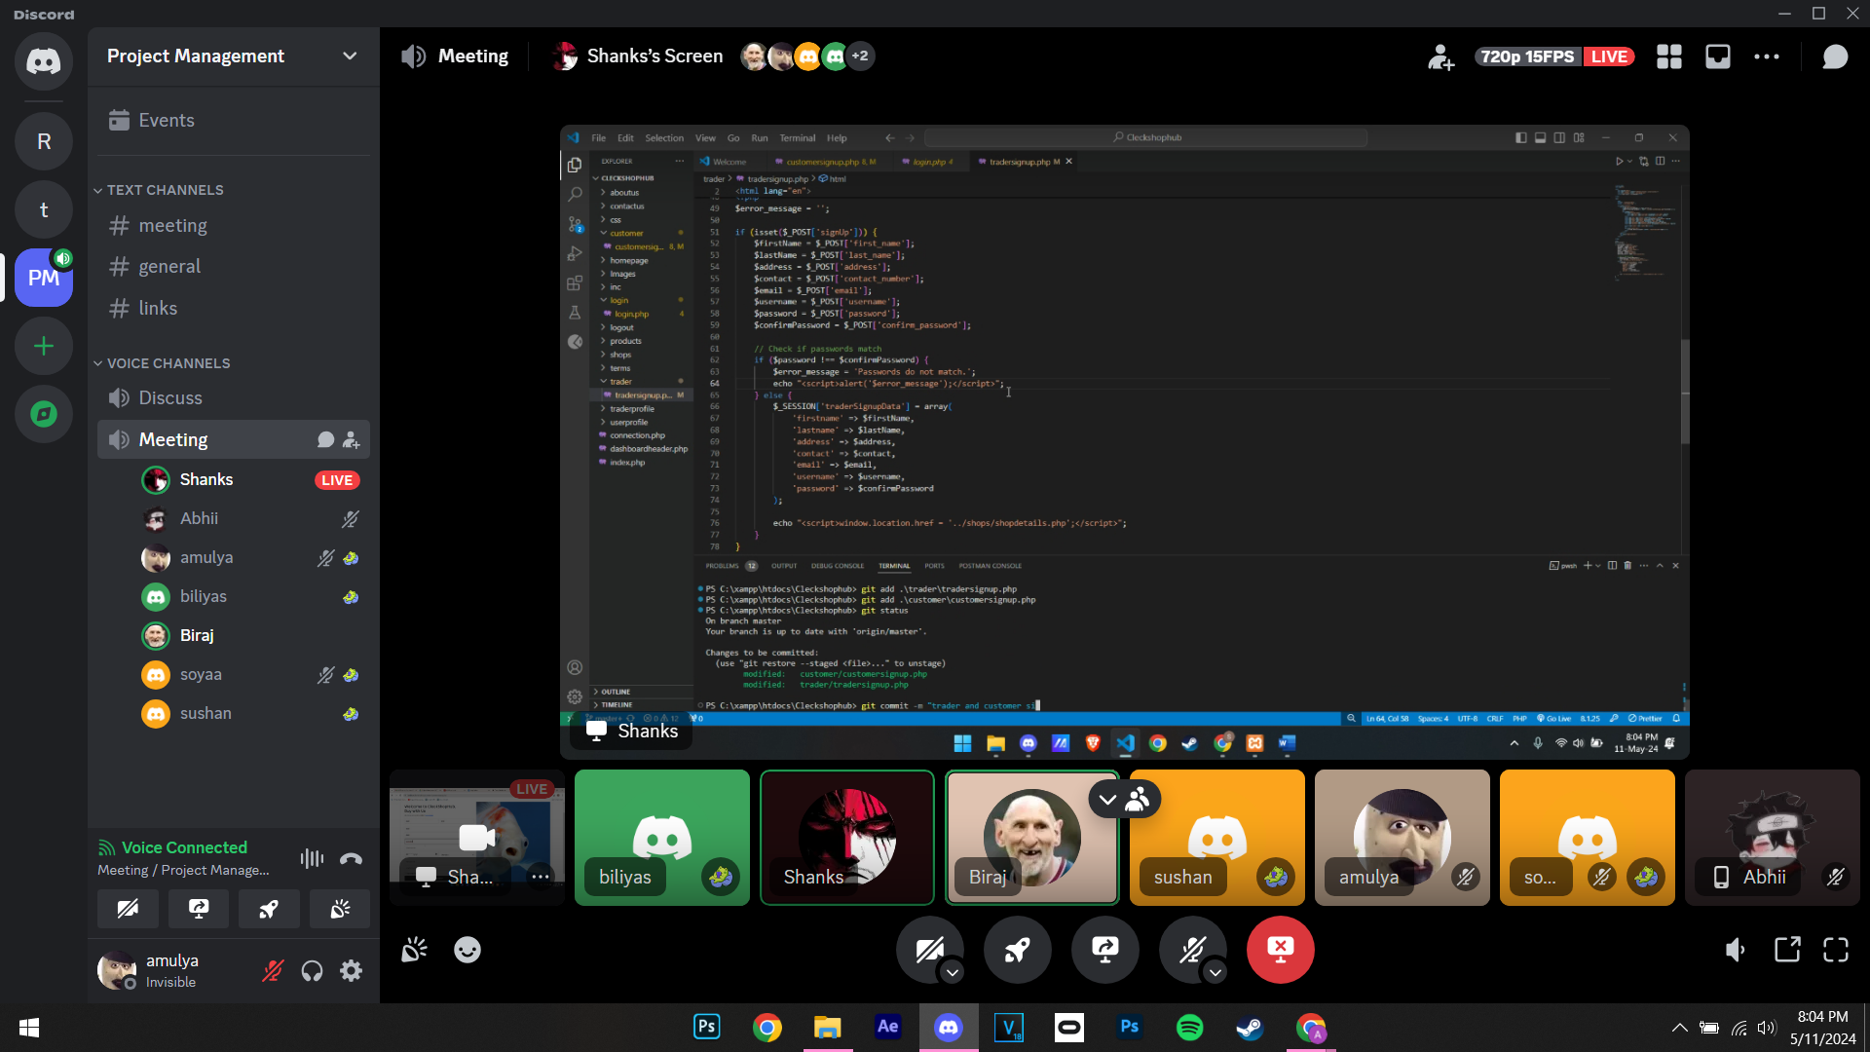

**Day 30 (12th May 2024) 10:15 am to 2:30 pm(Physical)**

* Made necessary changes to PHP files.

**Day 31 (15th May 2024) 7:00 am to 11am(Physical)**

* OTP verification through the mail.
* Continued with PHP, HTML, and CSS.

**Day 31 (17th May 2024) 7:00 am to 11am(Physical)**

* Continued with Admin Dashboard Frontend

**Day 32 (18th May 2024) 8:00 pm to 9:00 pm (Online)**

* Testing responsiveness of different dashboards.

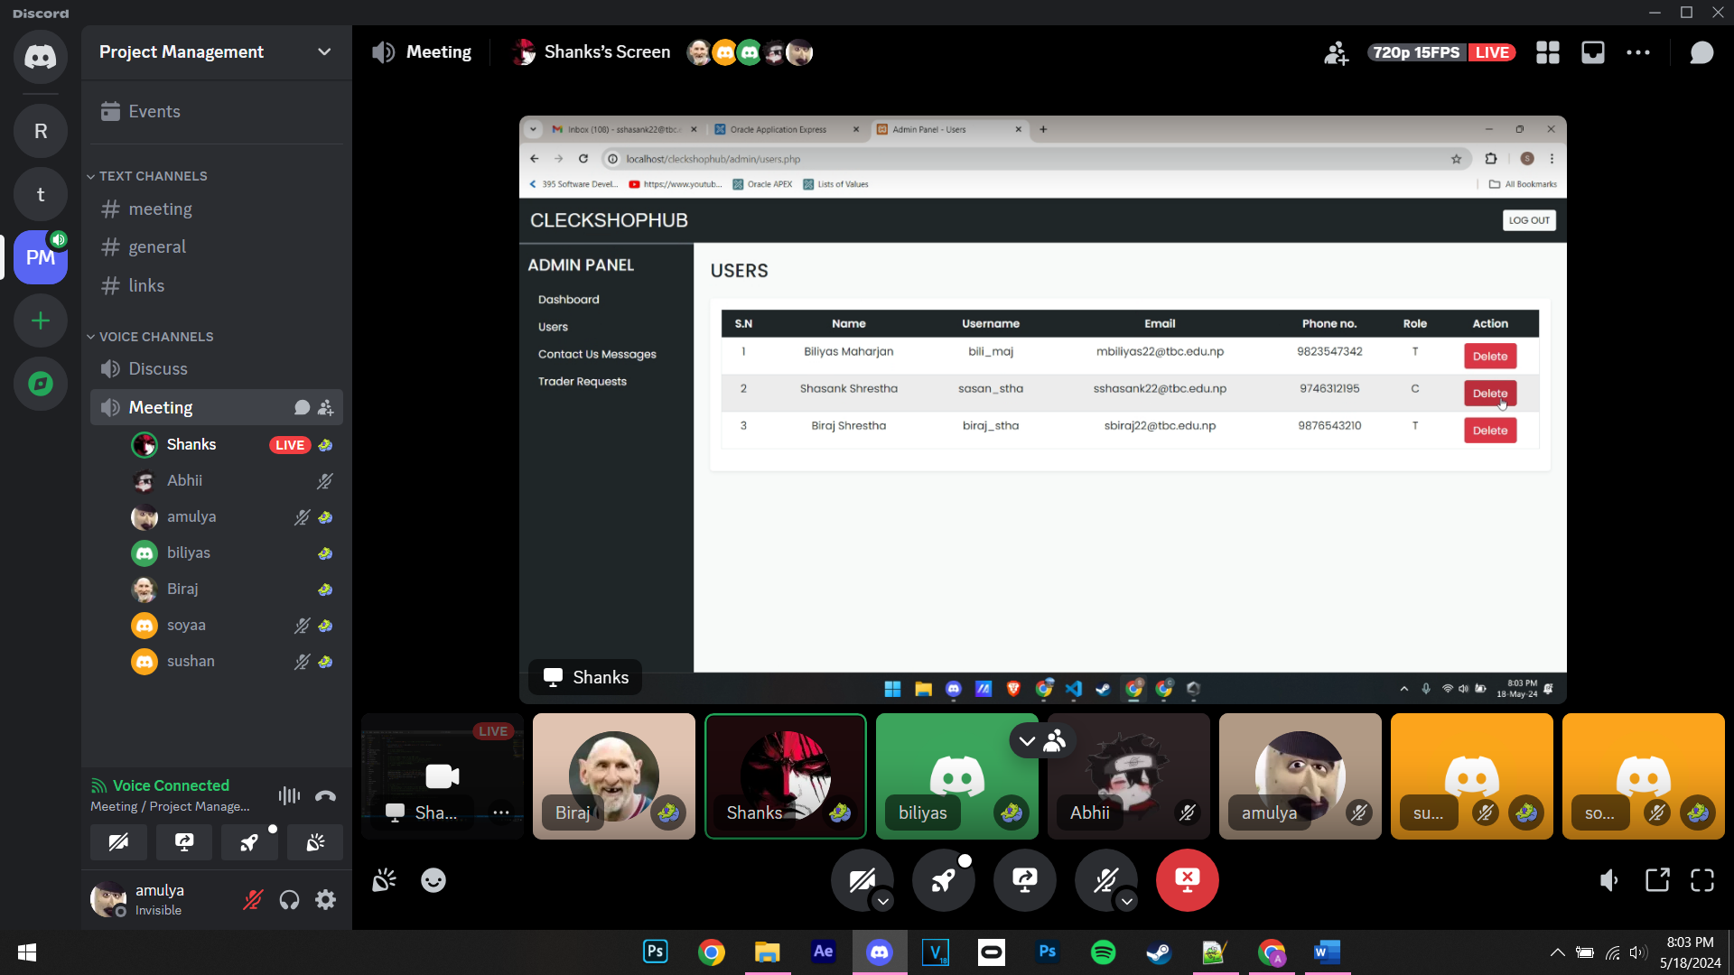

* Started discussion on the final portfolio submission.

**Day 33 (19th May 2024) 7:00 am to 11:20am(Physical)**

* Continued working on the final portfolio
* Made necessary CSS changes
* Testing codes

**Day 34 (20th May 2024) 7:00 am to 5:10 pm(Physical)**

* Testing by inserting products from the trader dashboard.
* Error solving

**Day 35 (21st May 2024) 9:00 am to 5:00 pm(Physical)**

* Started working on the review part
* Completed add-to-cart part

**Day 36 (22nd May 2024) 9:00 am to 5:00 pm(Physical)**

* Started working on PayPal.
* Worked on the checkout page and cart page.

**Day 37 (23rd May 2024) 9:00 am to 5:00 pm(Physical)**

* Started working on documentation.
* Paypal integration
* Worked on the “remember me “ part

**Day 38 (24th May 2024) 9:00 am to 3:30 pm(Physical)**

* Debugging
* Continued working on Documentation
* Finalized order confirmation page.

**Day 38 (25th May 2024) 11:00 am to 3:30 pm(Physical)**

* Prepared slides
* Website finalizing

**Day 39 (26th May 2024) 9:00 am to 5:30 pm(Physical)**

* Finalized website and documentation
* Submission of Final portfolio and presentation slides.